https://www.jdoodle.com/embed/v0/66YI
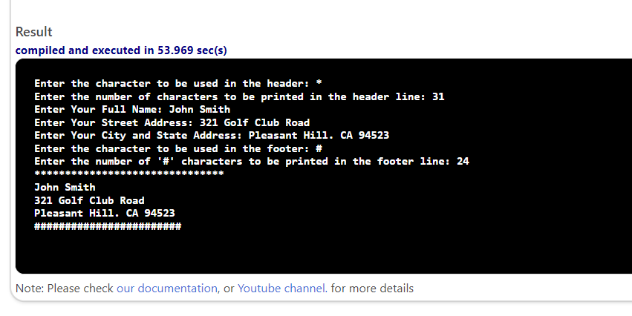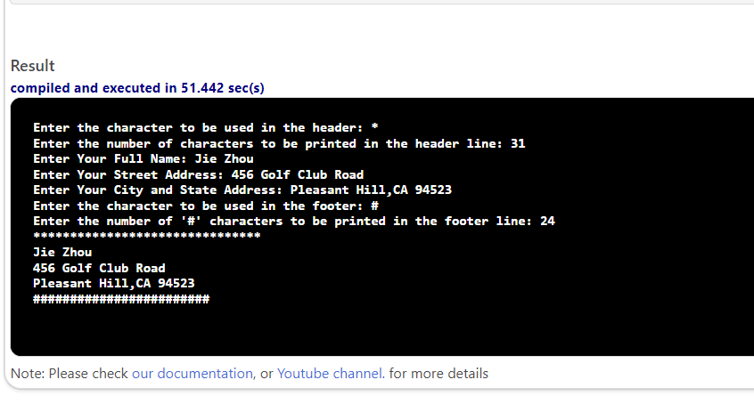

#include <iostream>
#include <string>
using namespace std;
void display2(char ch, int n) {
for (int i = 0; i < n; i++) {
cout << ch;
}
cout << endl;
}
int main() {
char chHead, chFoot;
int nHead, nFoot;
string name, saddr, caddr;
cout << "Enter the character to be used in the header: ";
cin >> chHead;
cin.ignore();
cout << "Enter the number of characters to be printed in the header line: ";
cin >> nHead;
cin.ignore();
cout << "Enter Your Full Name: ";
getline(cin, name);
cout << "Enter Your Street Address: ";
getline(cin, saddr);
cout << "Enter Your City and State Address: ";
getline(cin, caddr);
cout << "Enter the character to be used in the footer: ";
cin >> chFoot;
cin.ignore();
cout << "Enter the number of '" << chFoot << "' characters to be printed in the footer line: ";
cin >> nFoot;
cin.ignore();
display2(chHead, nHead);
cout << name << endl;
cout << saddr << endl;
cout << caddr << endl;
display2(chFoot, nFoot);
return 0;
}

